### **PROJECT** **TITLE**

### Optimizing User, Group, And Role Management With Access Control And Workflows

**Team Id: NM2025TMID17122**

**Team Members:**

**Team Leader:Ramya.B**

**Team Member:Nandhini.G**

**Team Member :Ragavi.Y**

**Team Member:Sahana.SU**

**Problem Statement:**

In a small project management team consisting of a Project Manager (Alice) and a Team Member (Bob), there is a need to efficiently manage project tasks and ensure accountability throughout the project lifecycle. The current system lacks clear role definitions, access controls, and a structured workflow, leading to confusion regarding task assignments and progress tracking.

Project Objective:

* **Enhance Security**
* **Improve Operational Efficiency**
* **Strengthen Compliance**
* **Boost Scalability**
* **Reduce Administrative Overhead**

Skills:

* **Role-Based Access Control (RBAC) Expertise**
* **Identity and Access Management (IAM)**
* **Workflow Design and Automation**
* **System and Technical Skill**

Milestone 1:Users

### Create Users

* 1. Open service now
  2. Click on All  >> search for users
  3. Select Users under system security
  4. Click on new
  5. Fill the following details to create a new user
  6. Click on submit

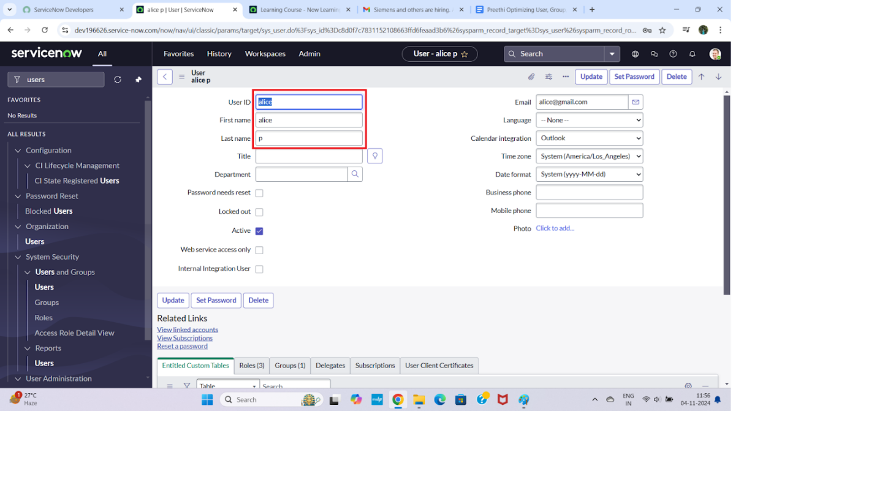

**Create one more user:**

* 1. Create another user with the following details
  2. Click on submit

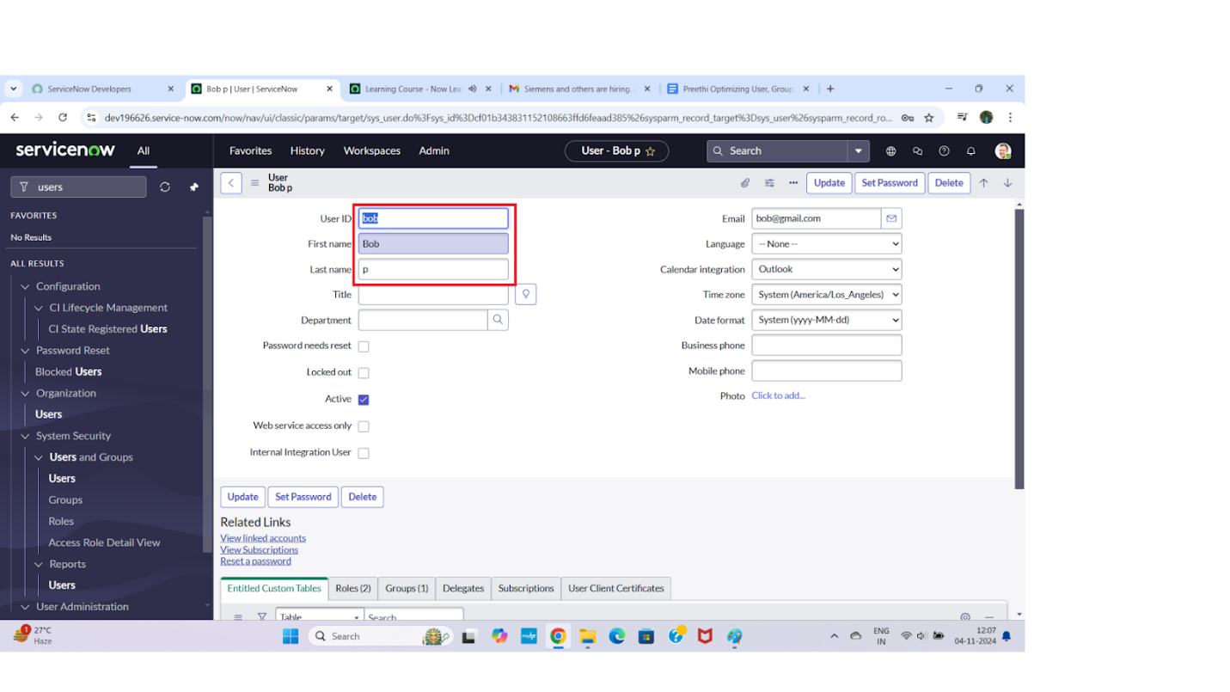

Milestone 2:Groups

Create Groups

Open service now.

Click on All >> search for groups

Select groups under system security

Click on new

Fill the following details to create a new group

Click on submit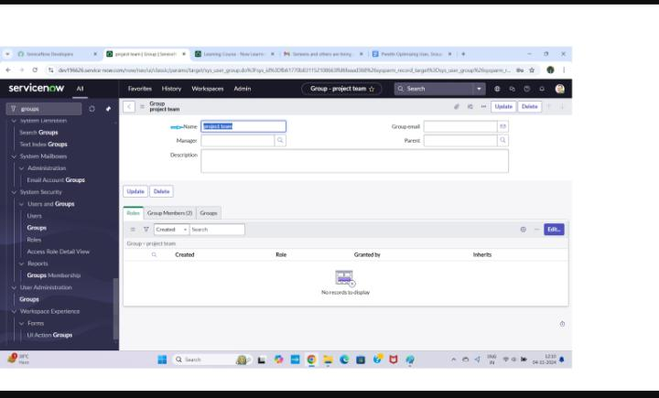.

Milestone 3: Role

* [**Workspace**](https://naanmudhalvan.smartinternz.com/Student/guided_project_workspace/29905)



* Optimizing User, Group, And Role Management With Access Control And Workflows
  + Users
  + Groups
    - Create Groups
  + Roles
    - Create Roles
  + Table
  + Assign Users To Groups
  + Assign Roles To Users
  + Application Access
  + Access Control List
  + Flow
  + Conclusion

### Create Roles

1. Open service now.
2. Click on All  >> search for roles
3. Select roles under system security
4. Click on new
5. Fill the following details to create a new role
6. Click on submit

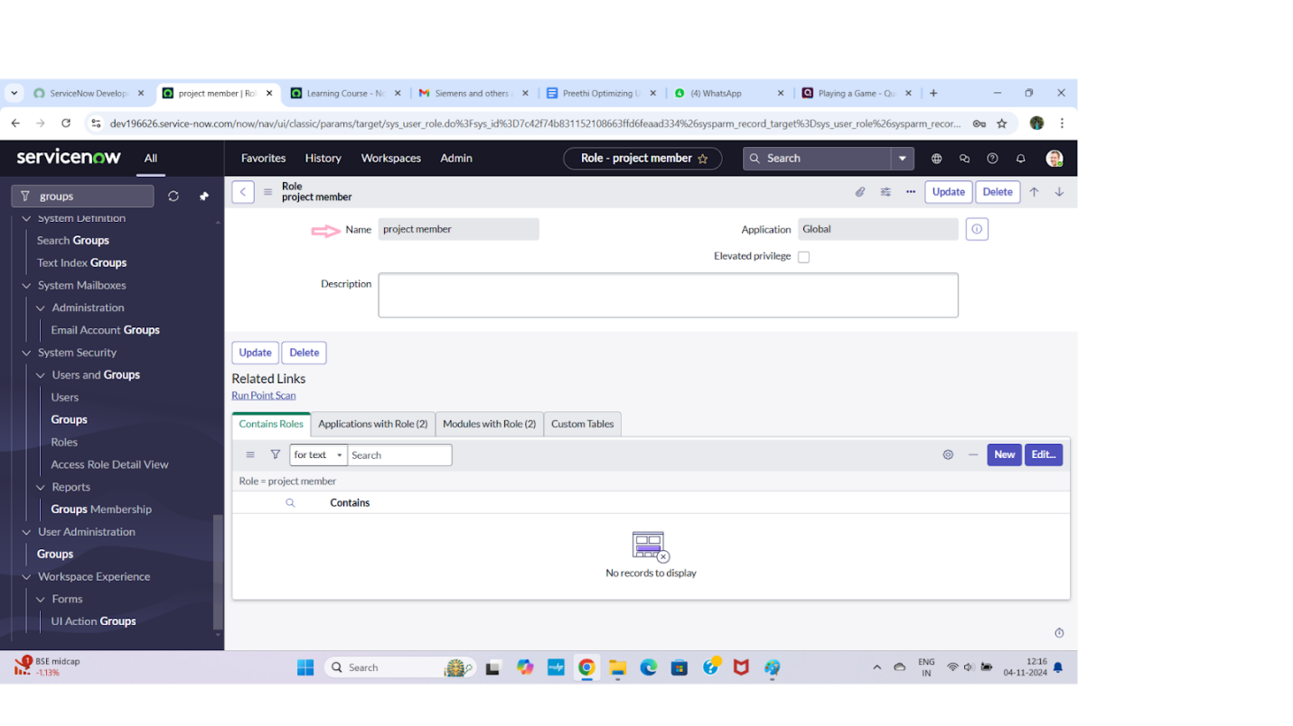

**Create one more role:**

             7.Create another role with the following details : Team member

             8.Click on submit

### Milestone 4: Table

### Create Table

* 1. Open service now.
  2. Click on All  >> search for tables
  3. Select tables under system definition
  4. Click on new
  5. Fill the following details to create a new table  
     Label : project table  
     Check the boxes Create module & Create mobile module
  6. Under new menu name : project table
  7. Under table columns give the columns

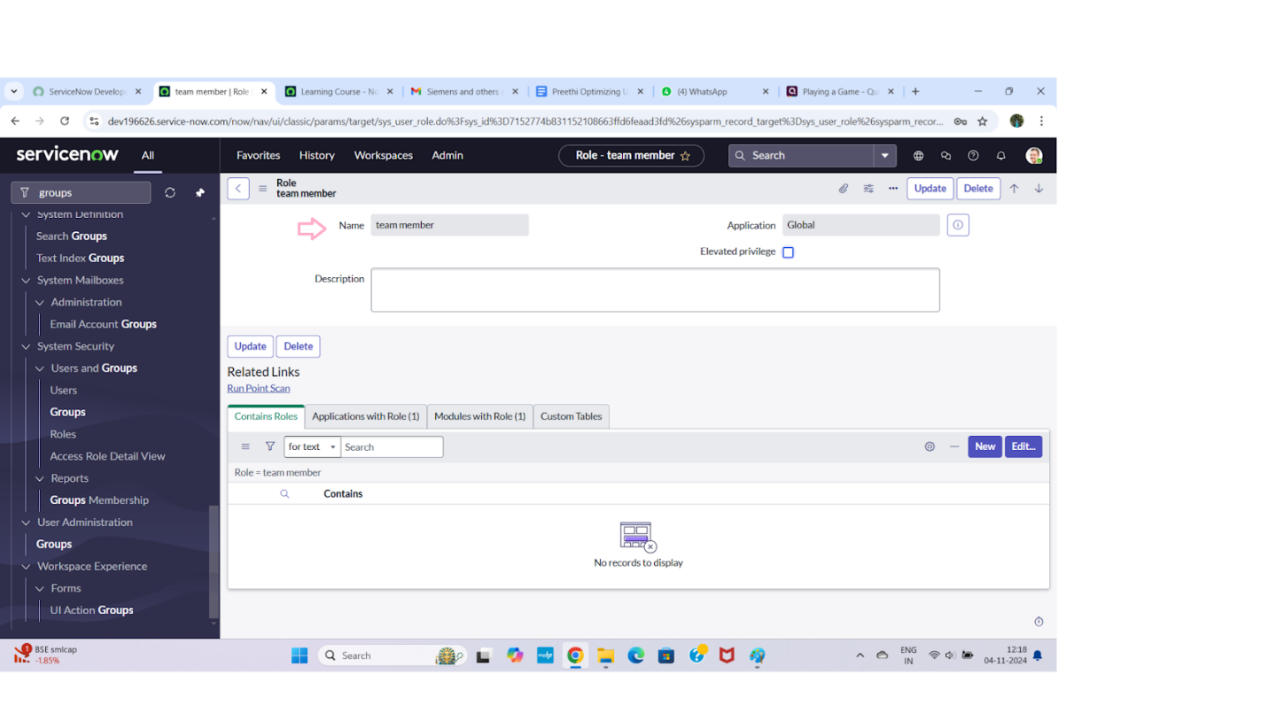

* 1. Click on submit

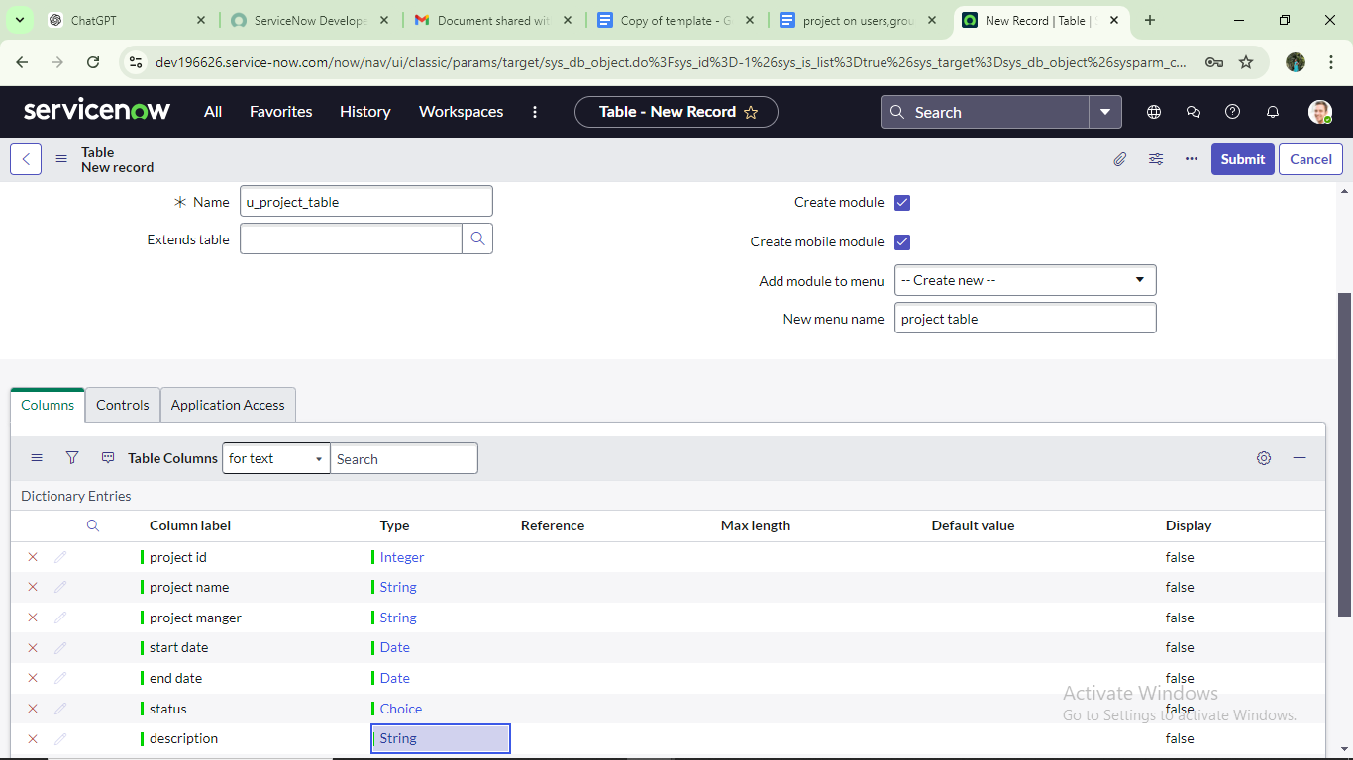

**Create one more table:**

   9.Create another table as: task table 2 and fill with following details.

   10. Click on submit.

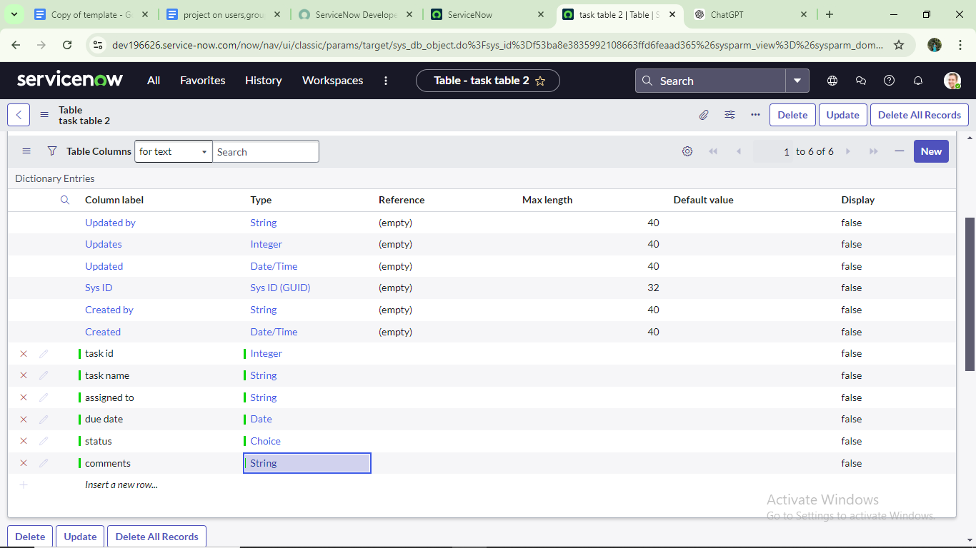

### Milestone 5: Assign Users To Groups

### Assign Users To Project Team Group

1. 1.Open service now.

2.Click on All  >> search for groups

3.Select tables under system definition

4.Select the project team group

5.Under group members

6.Click on edit

7.Select  alice p and bob p and save

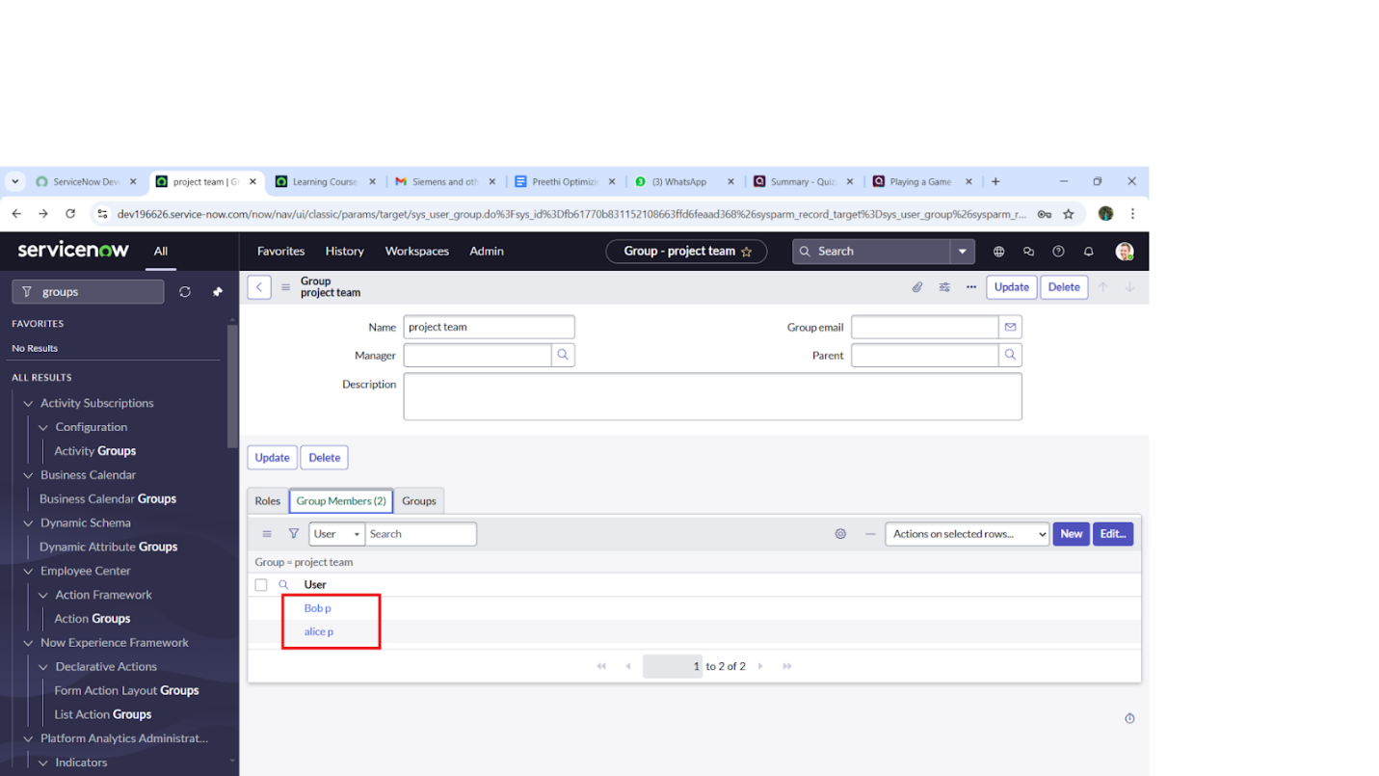

### Milestone 6: Assign Roles To Users

### Assign Roles To Alice User

## **1.Open servicenow.Click on All  >> search for user**

      2.Select tables under system definition

      3.Select the project manager user

      4.Under project manager

      5.Click on edit

      6.Select project member and save

      7.click on edit add u_project_table role and u_task_table role

      8.click on save and  update the form.

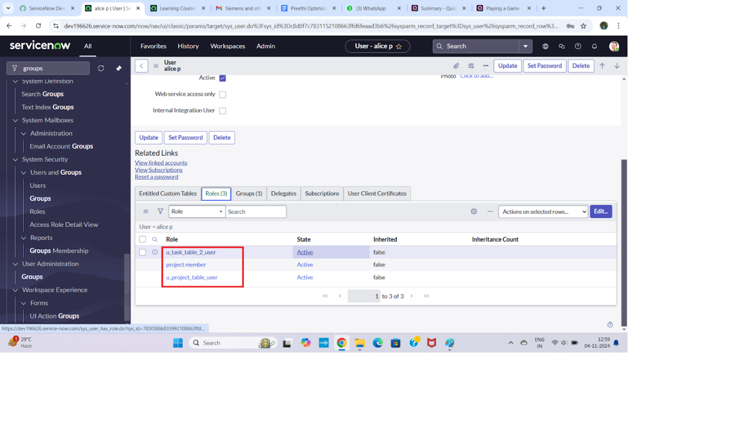

### Assign Roles To Bob User

## **1. Open ServiceNow. Click on All  >> search for user**

      2.Select tables under system definition

      3.Select the bob p user

      4.Under team member

      5.Click on edit

      6.Select team member and give table role  and save

      7. Click on profile icon Impersonate user to bob

      8. We can see the task table2.

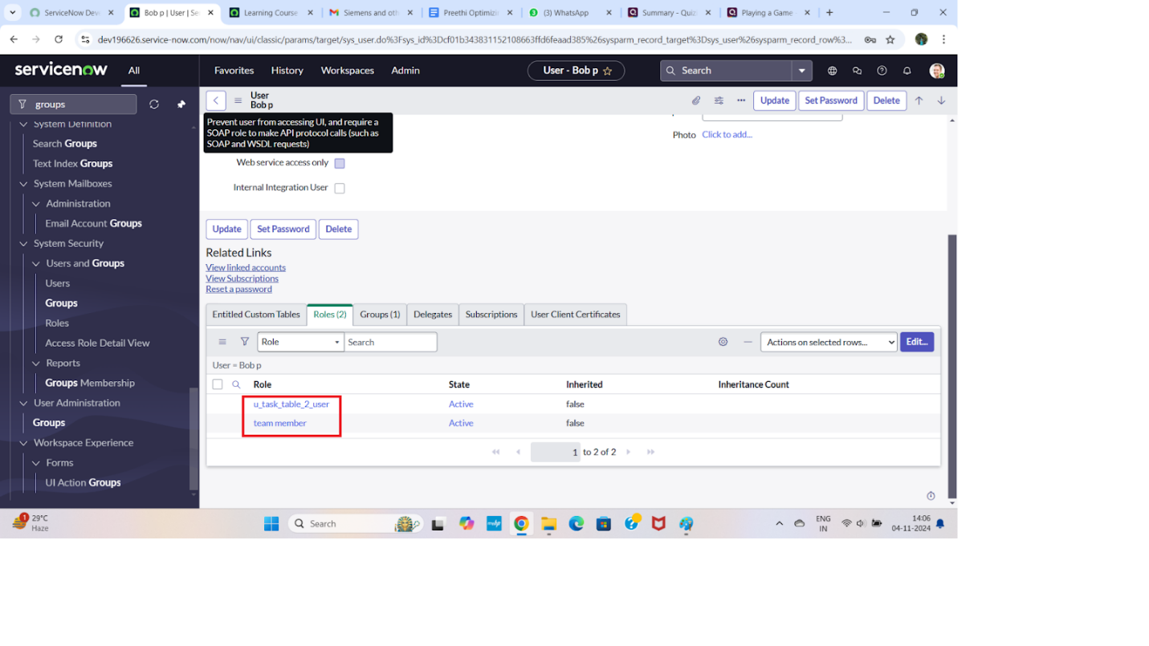

### Milestone 7: Application Access

### Assign Table Access To Application

* 1. while creating a table it automatically create a application and module for that table
  2. Go to application navigator search for search project table application
  3. Click on edit module
  4. Give project member  roles to that application
  5. Search for task table2 and click on edit application.
  6. Give the project member and team member role for task table 2 application

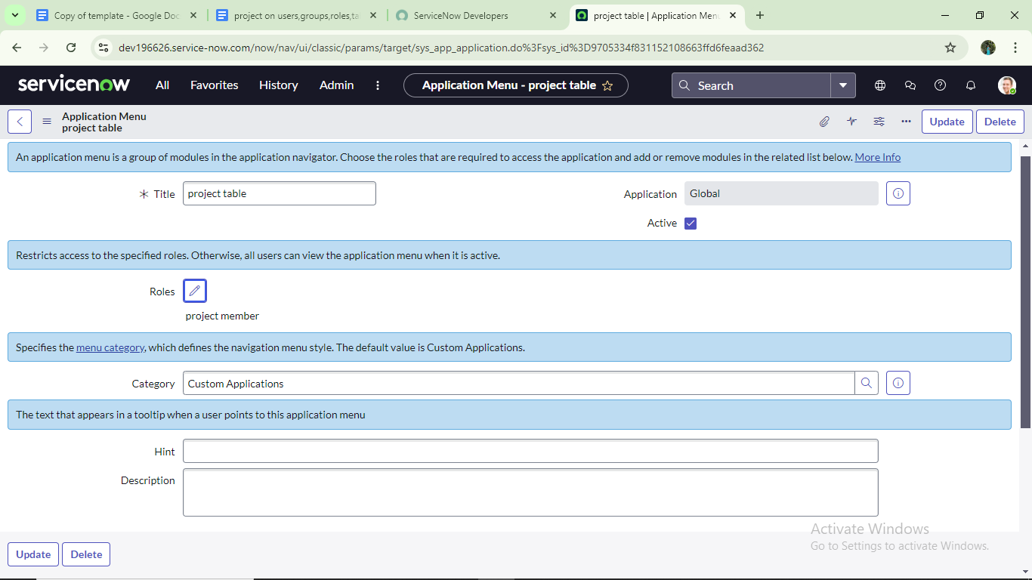

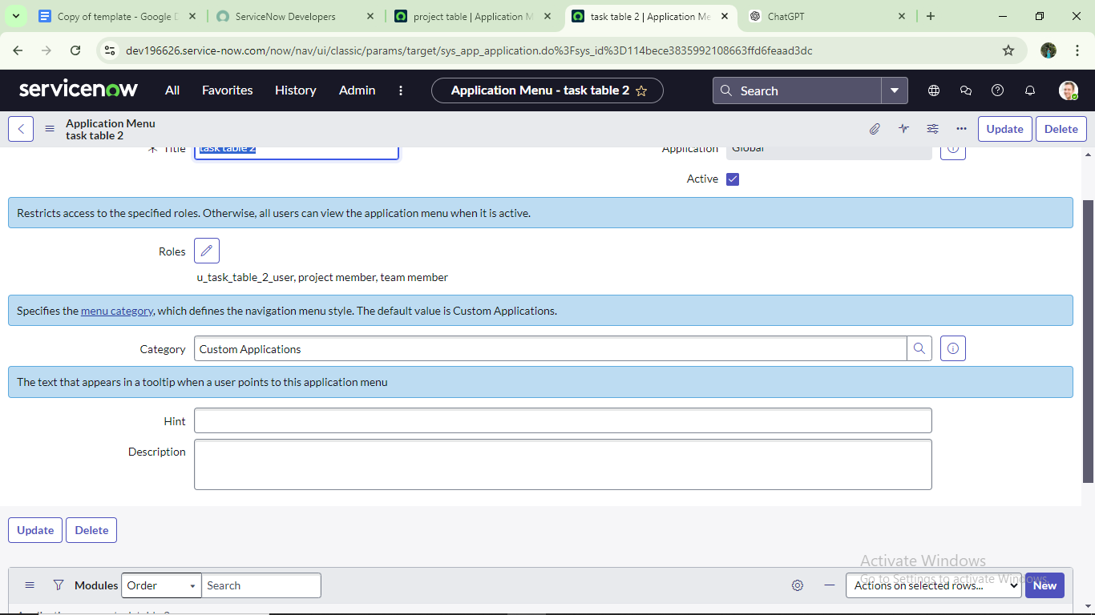

### Milestone 8: Access Control List

### Create ACL

* 1. Open service now.
  2. Click on All  >> search for ACL
  3. Select Access Control(ACL) under system security
  4. Click on elevate role
  5. Click on new
  6. Fill the following details to create a new ACL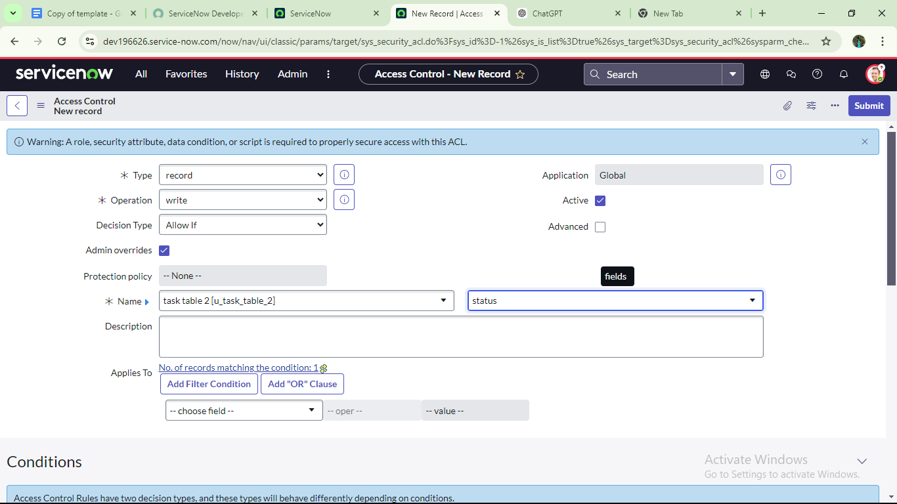
  7. Scroll down under requires role
  8. Double click on insert a new row
  9. Give task table and team member role
  10. Click on submit
  11. Similarly create 4 acl for the following fields

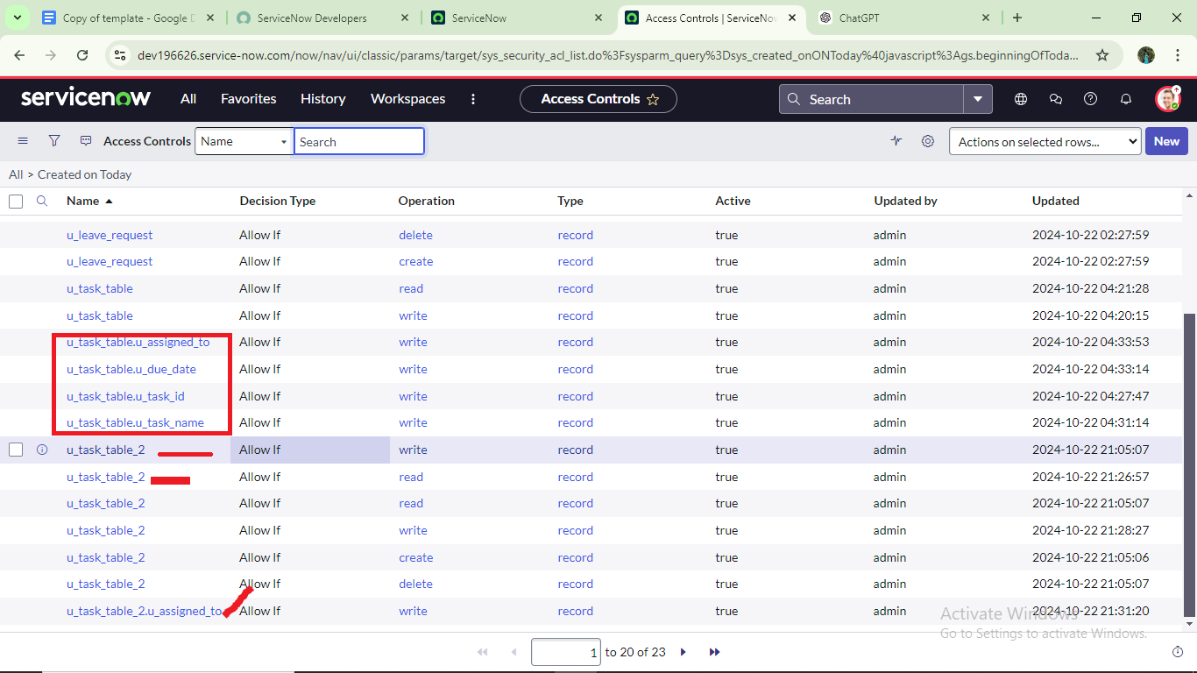

12.Click on profile on top right side

      13.Click on impersonate user

      14.Select  bob user

      15.Go to all and select task table2 in the application menu bar

      16. Comment and status fields are have the edit access

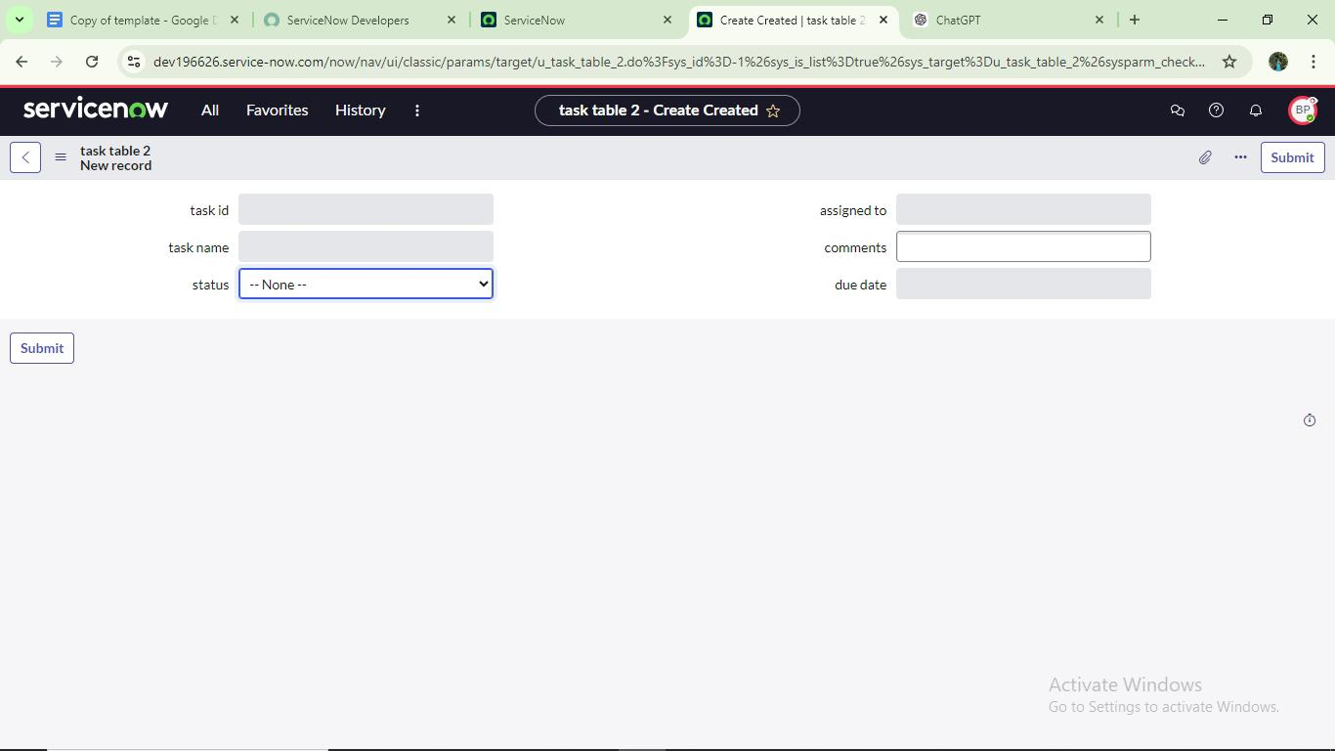

### Milestone 9: Flow

* Optimizing User, Group, And Role Management With Access Control And Workflows
  + Users
  + Groups
    - Create Groups
  + Roles
    - Create Roles
  + Table
    - Create Table
  + Assign Users To Groups
    - Assign Users To Project Team Group
  + Assign Roles To Users
    - Assign Roles To Alice User
    - Assign Roles To Bob User
  + Application Access
    - Assign Table Access To Application
  + Access Control List
    - Create ACL
  + Flow
    - Create A Flow To Assign Operations Ticket To Group
  + Conclusion

### Create A Flow To Assign Operations Ticket To Group

1. Open service now.
2. Click on All  >> search for Flow Designer
3. Click on Flow Designer under Process Automation.
4. After opening Flow Designer Click on new and select Flow.
5. Under Flow properties Give Flow Name as “ task table”.
6. Application should be Global.
7. Click build flow.

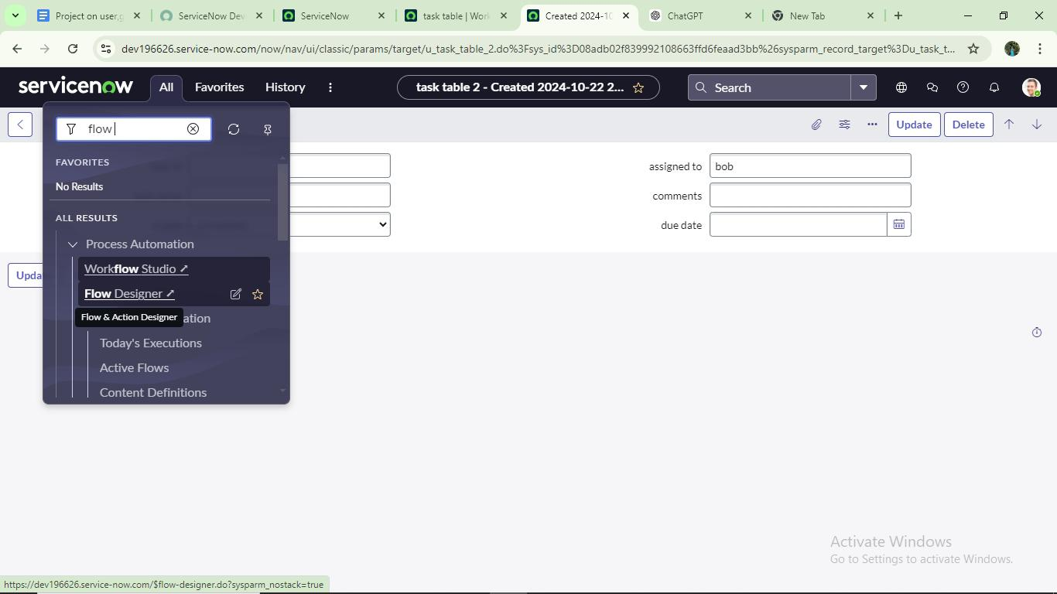

### Conclusion:

This scenario highlights a structured approach to project management, showcasing the roles of Alice and Bob within a workflow. With Alice's oversight and Bob's execution, the team effectively collaborates to ensure project success. The use of tables organizes key information,facilitating easy tracking of projects, tasks, and progress updates. Overall, this system promotes accountability, enhances communication, and leads to the successful completion of projects.